 |  | Consumer Research Expert
ConsumerInsight Report
(Travel Report `19)
Company | ConsumerInsight |  | E-mail | kwonyg@consumerinsight.kr
Query | Kwon, Younggyo / Director |  | Phone number | 02) 6004-7622
Issued | Thursday, Nov 6th 2019 |  | Pages | Total of 4 pages

‘NO-Japan’ aftermath…
Even the satisfaction of traveling to Japan falls sharply
ConsumerInsight, conducts a study of overseas travel experience in the past 1 year

- Japan, ranking falls to 28th among 32 major countries
- Ferry accident- Hungary dropped to 24th from 14th
- Switzerland, Croatia, and Spain remain as the top 3 in order
- By region, Bohol of the Philippines takes 1st place at the score in the 800s

Koreans’ satisfaction with traveling to Japan has deteriorated greatly. Not only the number of tourists was decreased from ‘Japan tour boycott’ but it also had an impact on the trip review. Among all the traveling countries, Switzerland, Croatia and Spain received an outstanding rate again this year as the top 3 in order. Bohol of the Philippines was the first Asian region receiving score in the 800s, taking the 1st place among regions (city) Koreans travel a lot.
In September, travel research specialized firm, ConsumerInsight asked a total of 13,958 adults who have travelled abroad in the past 1 year, to gather information on how they have traveled and how they evaluate the destination. The overall satisfaction score was calculated by adding ‘how satisfied are you’ and ‘recommendation intention’ of the country that was the main destination of the travel. There were 32 countries with more than 60 visitors (Hawaii, Guam and Saipan were considered as a state), and the average of the overall satisfaction score was 740 pts. (out of 1,000 pts.)[Figure 1].
■ 6 European countries in Top 10, still going strong
For the overall satisfaction by country, △Switzerland took the 1st place for the 2nd time after the season in 2017 to 2018 at 843 pts. [Reference. Swiss, Spain, and Croatia in Top 3 for outbound travel satisfaction]. △Croatia (820 pts.) stepped up to the 2nd place from the 3rd and △Spain was down by 24 pts. placing in 3rd place (800 pts.). Of the 32 countries, only three of these European countries scored more than 800 points and held the top three spots for two consecutive years. △Hawaii(798 pts.), △Austria(795 pts.), and △Czechoslovakia(793 pts.) took 4th, 5th, and 6th in rank respectively with a small score gap, and Singapore ranked 7th, which was the only Asian country in the top 10. △Saipan(779 pts.) ranked 8th, UK(772 pts.) 9th, and New Zealand(771 pts.) 10th, with Saipan and UK entering top 10 for the first time. The Top 10 was consist of 6 European countries, 2 South Pacific countries, and 1 each in North America and Asia, showing strength for Europe.
■ Satisfaction in Korea-related events/incidents has plummeted
The satisfaction change in regions where major incidents and accidents occurred was noticeable. Japan, which boycott movement is happening due to the trade war, fell by 65 pts. to 675 pts. this year, from 740 pts. last year, falling to 28th in rank from 18th. Also, Hungary, where the Korean group tour ferry sank, fell by 54 pts. from 759 pts. last year and scored 705 pts. this year, with the rank drop by 10 steps, placing in the 24th. For both countries, psychological factors such as the decline in the destination image or the reputation seem to be the main reason for the satisfaction decline, rather than the deterioration of the attractiveness of actual tourism resources or the convenience of tourism.
■ Rapid rank change in Asian countries and the reorganization of short-range outbound travel market
For the most visited Asian countries by Koreans (Japan · Vietnam · Thailand · China · Philippines · Taiwan · Malaysia · Indonesia), the overall satisfaction score was compared by major destinations. 8 countries and 32 regions were included in the comparison list based on a sample size of 30 or more. The regional average overall score was 688 pts., which was 50 pts. lower than the average of 32 countries (740 pts.)[Figure 2].
△Philippines Bohol was the first Asian region to record 800 pts., ranking top 1. It was rose by 52 pts., stepping up 5 in ranks from last year. Considering that only the three European countries exceeded 800 pts. at the national level, Bohol has proved to be one of the world’s most prominent travel destinations. Next, △Vietnam PhuQuok was newly included in the evaluation and ranked 2nd with 782 pts. △The 3rd place was Bali, Indonesia, up 52 pts. and 15 ranks higher than last year. The scores of all the top three regions have increased rapidly or newly included in the evaluating regions, indicating that the short-range outbound travel market is reshaping. The 4th place was Nagoya, Japan (749 pts.) and the 5th place was Taipei, Taiwan (745 pts.). In addition, Chiang Mai in Thailand, Kota Kinabalu in Malaysia and Hunan in China were the regions with the highest overall satisfaction in each country.
Japan had dropped by more than 50 pts. in all regions(Sapporo, Okinawa, Kyoto, Fukuoka, Osaka, and Tokyo) excluding Nagoya, with Kyoto, Fukuoka, Osaka, and Tokyo scoring in the 700s. Just a year ago, Japan had its 4 regions in top 5, and it was rated as the most popular and beloved outbound destination for Koreans. This tells us that the satisfaction of tourists' outbound travel destinations is influenced not only by travel quality but also by emotional factors such as the relationship with their country and national image. This is worthy of reference in terms of travel industry strategy.
ConsumerInsight tourism industry research lab surveyed experience and evaluation on 1 night or over overseas traveling in the past 1 year. 800,000 IBP (Invitation Based Panel) of ConsumerInsight was used as sampling frame to survey 25,724 people, while sampling used proportional quota by gender∙age∙region according to the demographic ratio. Data collection used e-mail and mobile phone. The survey results and analysis reports can be viewed at www.consumerinsight.co.kr/etravel and the summary of the survey results of year 2018 and 2019 are downloadable. (Download Reports)

For-more-Information
Kwon, Younggyo / Director | E. kwonyg@consumerinsight.kr | T. 02)6004-7622

[Figure1] Overseas Travel overall satisfaction - Country
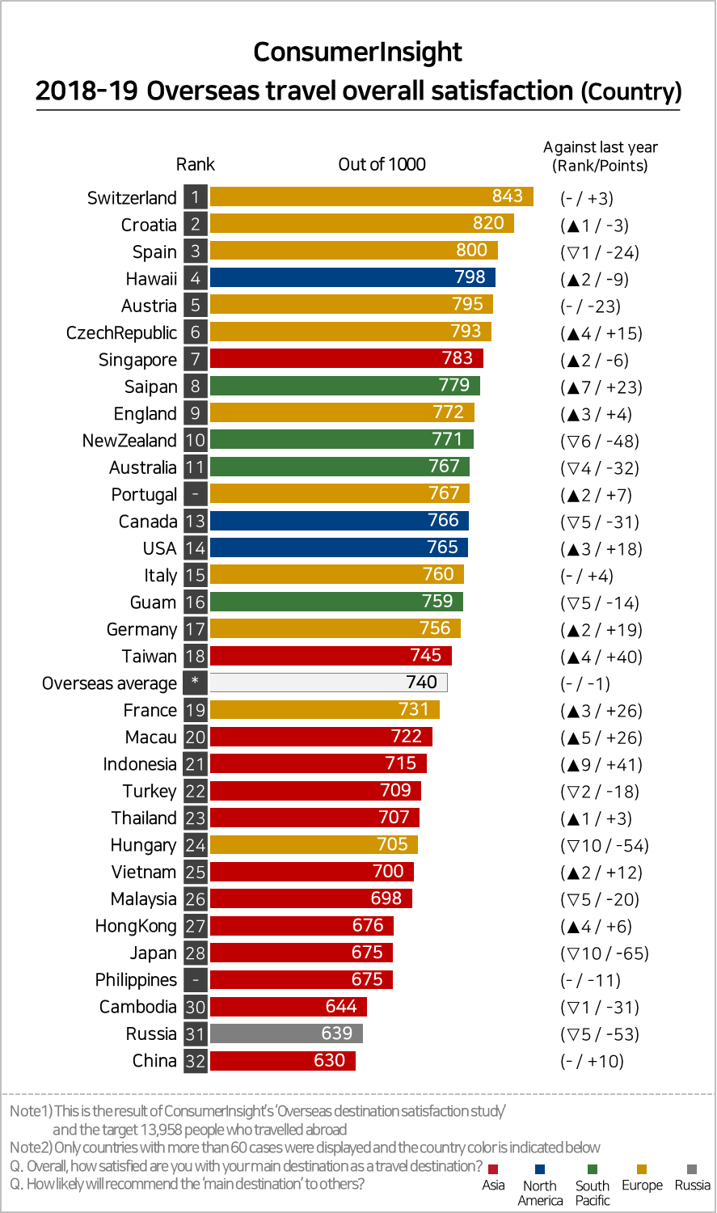

[Figure2] Overseas Travel overall satisfaction – Region
